

UNDERGRADUATE PROJECT REPORT

|  |  |
| --- | --- |
| **Project Title:** | **Book Recommendation Using Deep & Cross Network** |
| **Surname:** | **Cheng** |
| **First Name:** | **Arnold** |
| **Student Number:** | **201918020422** |
| **Supervisor Name:** | **Joojo Walker** |
| **Module Code:** | **CHC 6096** |
| **Module Name:** | **Project** |
| **Date Submitted:** | **May 5, 2023** |

# **Declaration**

Here, students would sign a statement indicating that they adhered to appropriate academic conduct in carrying out their final project.

# **Acknowledgment**

Here, students are given the opportunity to thank those who have provided you with assistance and support.

# **Table of Contents**

**Declaration** i

**Acknowledgment** ii

**Table of Contents** iii

**Abstract** iv

**Abbreviations** v

**Glossary** vi

**Chapter 1 Introduction** 1

**1.1** **Background** 1

**1.2** **Aim** 1

**1.3** **Objectives** 1

**1.4** **Project Overview** 1

**1.4.1** **Scope** 1

**1.4.2** **Audience** 1

**Chapter 2 Background Review** 2

**Chapter 3 Methodology** 3

**3.1** **Approach** 3

**3.2** **Technology** 3

**3.3** **Project Version Management** 3

**Chapter 4 Results** 4

**Chapter 5 Professional Issues** 5

**5.1** **Project Management** 5

**5.1.1** **Activities** 5

**5.1.2** **Schedule** 5

**5.1.3** **Project Data Management** 5

**5.1.4** **Project Deliverables** 5

**5.2** **Risk Analysis** 5

**5.3** **Professional Issues** 5

**Chapter 6 Conclusion** 6

**References** 7

**6.1** **Formatting Requirements** 7

**6.2** **Written Presentation** 7

**Appendices** 8

# **Abstract**

Up to 250 words, concise outline of background, aims, results, and achievements.

***Keywords: This is part of the “Abstract” section. Students are to provide at least 3 keywords that best describe their project topic. Do not list more than 8 keywords.***

# **Abbreviations**

This section should have the definition of any abbreviations used in the report

# **Glossary**

This section should have the definition of all the keywords you stated in the “Abstract” section. You can also define other relevant keywords. Particularly, if your final project report includes rare, unfamiliar, specialized, or made-up words or terms, the glossary serves as a dictionary for the reader to reference throughout their reading of the project report. (Note: this section should only contain definitions for specific terms in the project report. It does NOT function as an ordinary dictionary. Hence, common words related to the Computer Science and Software Engineering disciplines should NOT be included in this list.)

# **Introduction**

*This is an update of the Introduction from your previous reports. Students are to also incorporate the feedback from their supervisor. Also, include subsequent ideas and research that you have discovered.*

## **Background**

This section should describe the overview of the topic and motivations. Provide appropriate references wherever necessary.

## **Aim**

The overall goal of your project should be stated here. It is recommended that each project should have a single aim.

## **Objectives**

Students are to state the several tasks/steps that would help them to accomplish the overall aim/goal of their project.

## **Project Overview**

(NB: Most students are working either on a software development-based project or a machine learning/deep learning-based project. Hence, in section 1.4, students must adopt the appropriate theme/content depending on their project topic.)

### **Scope**

The scope of a software development project should answer the questions: what will the software do? How will the software work? The scope for a machine learning/deep learning-based project should focus on answering the questions: what is the purpose of the study? How significant is the study?

### **Audience**

The audience for a software development project should focus on who is the software for? The audience for a machine learning/deep learning-based project should focus on who will benefit from the findings.

# **Background Review**

This chapter is an update of the Background Review from your previous reports, using the feedback you received from your supervisor. Compare existing approaches and include a themed literature review, with a critical appraisal of the sources. Provide appropriate and sufficient references. Also include *the feedback you received from your supervisor. You can add any additional key sources that you have discovered.*

Students doing software development-based projects can write their background review by providing a **summary of existing approaches (e.g., competitive analysis, if appropriate),** and others doing research-oriented projects (machine learning & deep learning projects) can write their background review by stating **a summary of related literature (e.g., annotated bibliography, or initial literature review, with a brief summary of sources).**

**Annotated Bibliography aids as in doing a good literature review. It is not the literature review. However, your final background review must be paragraphs with appropriate citations. Whenever appropriate, a table can be adopted.**

# **Methodology**

## **Approach**

A brief description of the Deep & Cross Network model

The Deep & Cross Network model we will refer to as the DCN model below:

In this project, the DCN (Deep & Cross Network) model is employed as the core recommendation model for the proposed solution. The complete DCN v1 model is shown in the figure:

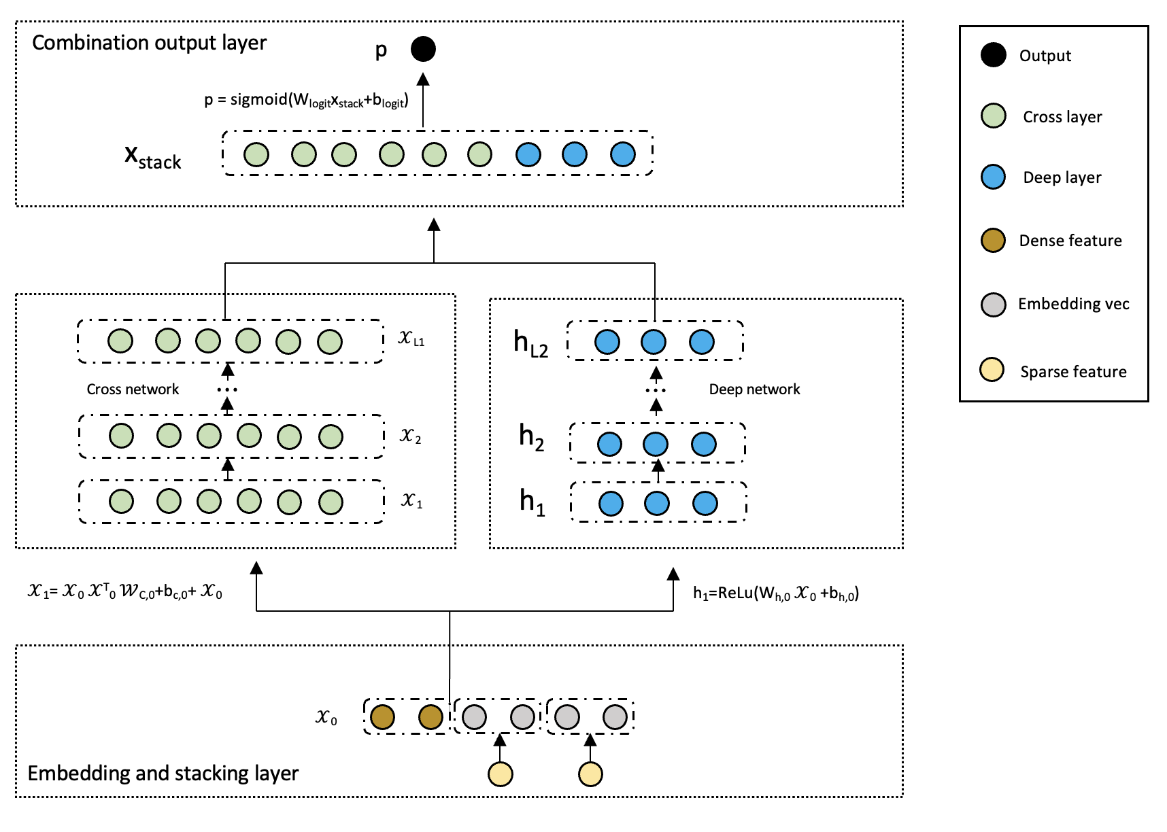

Figure 1: DCN v1 Model

DCN can be divided into four main parts. The first part, located at the bottom, is the "Embedding and Stacking Layer". This layer involves the process of converting discrete features into dense vectors using an embedding technique, and then stacking these embedding vectors with the continuous features to form a unified input vector for the subsequent layers.

When dealing with input data that exhibit both discrete and continuous characteristics, such as in network-scale recommendation systems like click-through rate (CTR) prediction, the input is typically comprised of categorical features, such as "country=USA". These categorical features are frequently represented using one-hot encoding, resulting in a binary vector such as "[0,1,0]". However, this approach often results in a high-dimensional feature space when dealing with large vocabularies.

To reduce the dimensionality, the embedding process is used to convert these discrete features into a dense vector of real values (often called an embedding vector):

= (2)

Then, superimpose the embedding vector with the continuous eigenvector to form a vector:

= (3)

The stitched vector 0 will serve as input to our Cross Network and Deep Network

The second and third parts are the "Cross Network" and the "Deep Network", respectively, which are in the middle of the architecture. The Cross Network utilizes explicit feature interactions to capture the pairwise correlations between different features, while the Deep Network leverages the power of deep neural networks to learn hierarchical representations of the input data.

The core idea of cross network is to apply explicit feature intersections in an efficient way. A cross network consists of intersecting layers, each with the following formula:

= (4)

A few parameters of the cross-network limit the model capacity. To capture highly nonlinear interactions, the model introduces a deep network in parallel.

A deep network is a fully connected feedforward neural network, and each depth layer has the following formula:

(5)

Finally, the top part of DCN is the "Combination Output Layer", which combines the outputs from the Cross Network and Deep Network to produce the final prediction result. This layer plays a crucial role in integrating the complementary strengths of the two networks and improving the overall performance of the model.

The link layer connects the outputs of the two parallel networks and passes through a full link layer to get the output:

(6)

The explanation of DCN v2 model calculation principle.

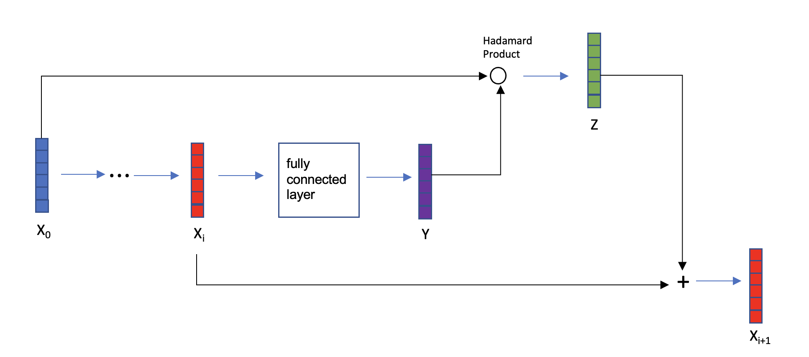

Figure2: Cross-layer

The cross-layer is the fundamental building block of a cross-network, and the figure1 is the structure of a single cross-layer. Given an input vector 0 that passes through neural network layers, the output vector is i. Taking the i-th cross layer as an example, the vector i is fed into a fully connected layer, which generates another vector Y. The lowest-level vector 0 is then subjected to Hadamard product with vector Y to produce the output vector Z. Vectors i and Z represent input and output, respectively, and the sum of these two vectors yields i+1 (similarly to the skip connections in ResNet). Vector i+1 represents the output of the i-th cross layer, while vectors 0 and i are inputs to this layer, and all parameters are contained within the fully connected layer.

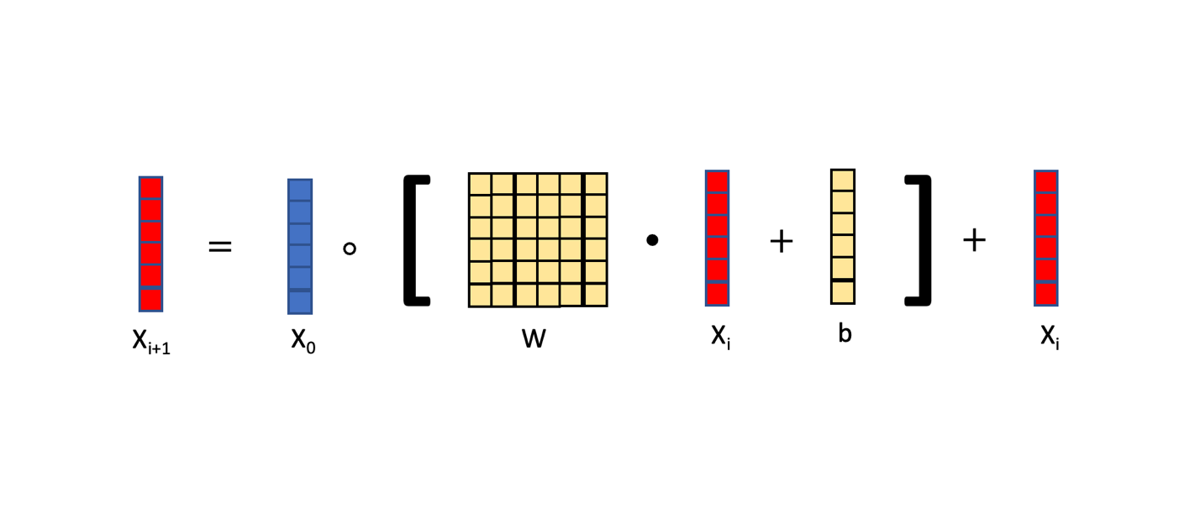

Figure3: formula of Cross-layer

The cross-layer can be represented by the equation in figure 3. The input of the cross-layer consists of two vectors, 0 and i. Here, 0 represents the input at the lowest layer of the neural network, while i represents the input to the i-th layer of the neural network. The square bracketed section denotes a fully connected layer, which computes the product of matrix W and vector i and adds vector b. The output of the fully connected layer is a vector with the same size as the input vector . The matrix W and the vector b are the parameters of the fully connected layer, which need to be updated during training using gradient descent. Finally, the element-wise multiplication (Hadamard product) between the vector 0 and the output of the fully connected layer is taken, followed by addition with vector i. The resulting vector is denoted as i+1, which serves as the output of the cross-layer. Notably, both the input and output are vectors with the same shape.

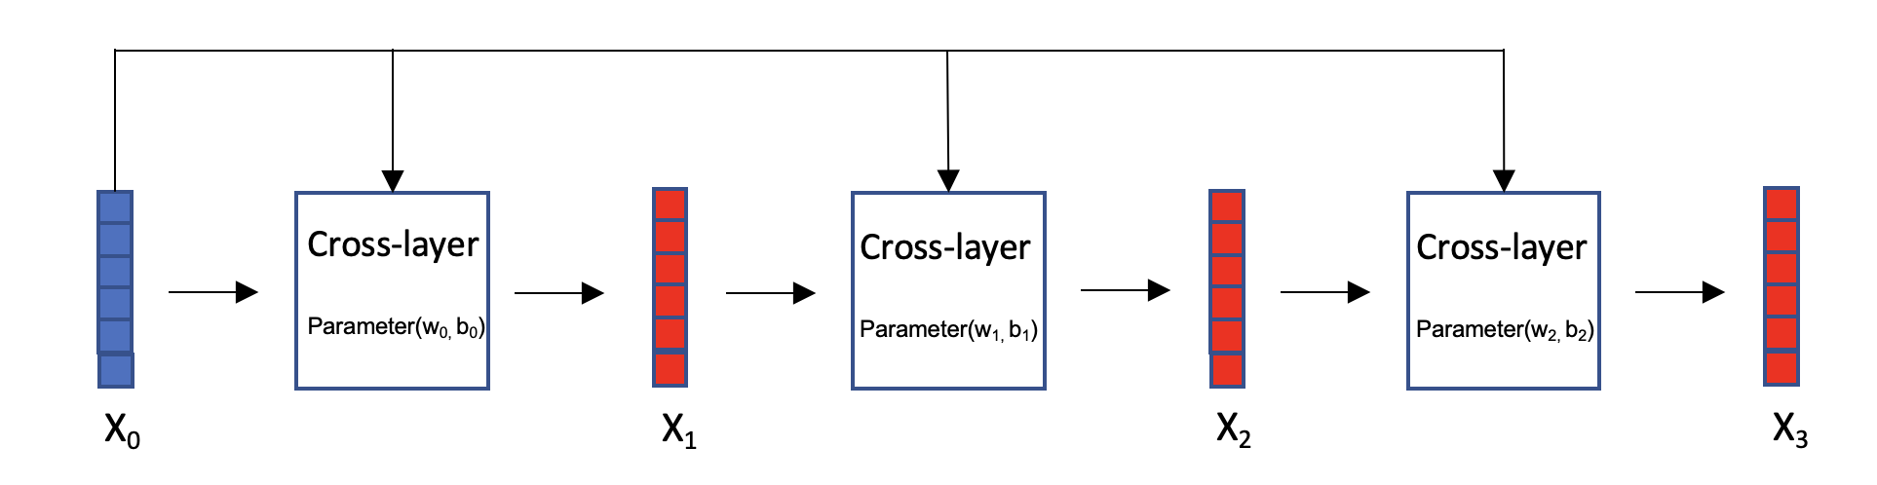

Figure4: Cross network

Cross network, as figure 4: Vector 0 is the input of the cross-network, which is fed into a cross-layer with parameters W0 and b0, resulting in output vector 1. Then, 1 is fed into the next cross-layer, along with 0, both of which serve as inputs to this cross-layer. The parameters for this cross-layer are W1 and b1, and the resulting output vector is 2. This process is repeated iteratively.

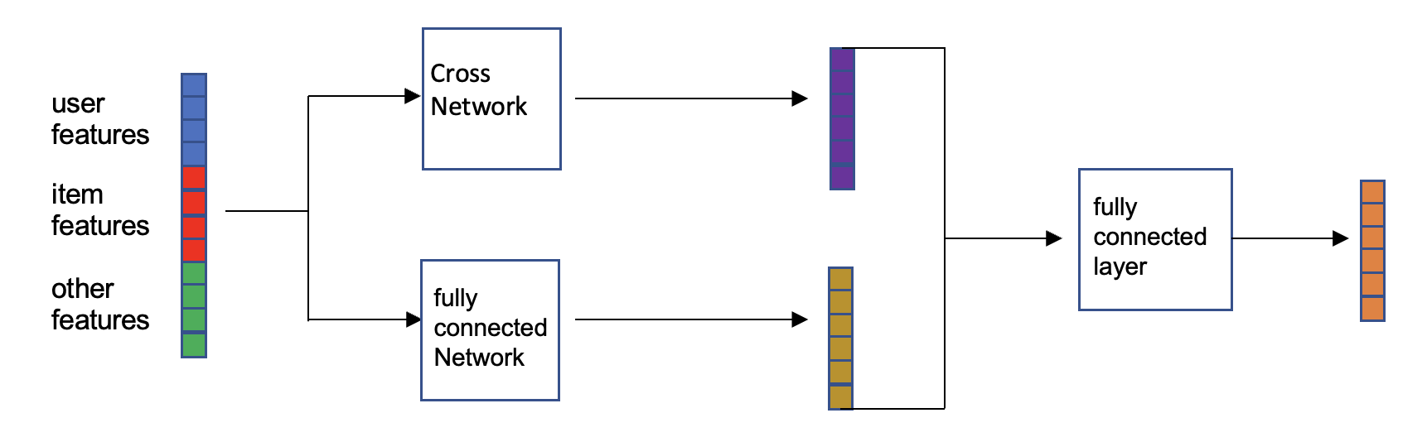

Figure5: Deep & Cross Network

Deep cross network (DCN) is a combination of cross network and fully connected network. In recommendation systems with ranking models, the input includes user features, item features, and other features, which are concatenated and fed into two neural networks in parallel: a fully connected network and a cross-network. Each neural network outputs a vector, which is then concatenated and fed into a fully connected layer that outputs a vector. The concatenation of the fully connected network, cross-network, and fully connected layer is the DCN. The DCN can be used for both recall and ranking.

## **Technology**

These are the hardware and software that I'm going to use in the project

|  |  |
| --- | --- |
| hardware | software |
| Macbook pro 16 INCHES  SoC: m1 pro  gpu: a5000(rent from autodl) | Colab  Pytorch environment  Google Drive  Language: python  Jupyter notebook  Autodl |

Table1：tools

## **Project Version Management**

I use both local storage and Google Cloud to manage my projects, and the papers and data are stored locally before being uploaded to a folder in the cloud and synced. When the codes have been done. It will automatically upload the code to Google Cloud after moving it to the cloud folders. Here is the link: https://drive.google.com/drive/folders/1-1QdZNElGqMBr4bonCHi_IzAgdo7kKHM?usp=sharing

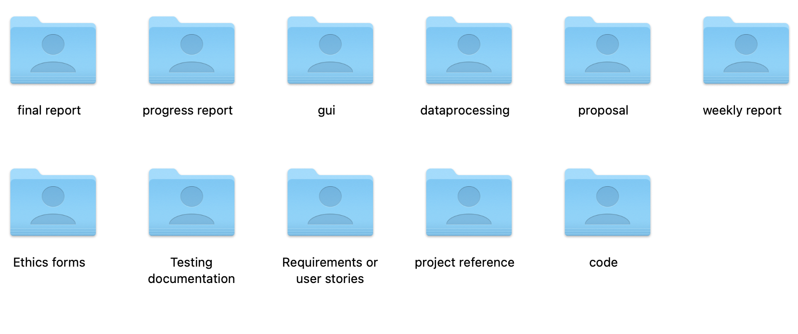

Figure6: management folders

# **Results**

Here students are to provide detailed descriptions and documentation of results and testing. Critical evaluation and discussion of results, issues encountered constraints, limitations, and originality.

The subsection layouts of this section mostly depends on the type of project that the student is carrying out. Students can introduce subsections that will help the readability of their work.

For instance, students doing software development-based projects should provide the detailed use of their software in this chapter. Screenshots (images) of their graphical user interfaces can be depicted in this chapter. Other relevant details about the testing and evaluation of their software can be stated here as well.

Also, students doing research-oriented projects (machine learning & deep learning projects) should state the results of their model training, validation and testing. Use appropriate graphs and figures to illustrate your results. Results from case studies and ablation study of hyper-parameters should be stated here. In a situation where a machine learning-based project was deployed as a web or mobile application, students are to provide details of functionality tests.

# **Professional Issues**

## **Project Management**

### **Activities**

Here are the activities to accomplish each goal:

|  |  |  |  |
| --- | --- | --- | --- |
| Object | Activities | complete | uncompleted |
| 1. completes the research, study, and research of the recommender system. | a) Conduct a systematic search of similar software  b) Create a feature comparison table  c) Complete a literature search  d) Perform a literature review  e) Conduct a user survey | ALL | NULL |
| 1. completes the learning and research of deep learning. | 1. learning online course of deep learning 2. research of the model 3. collection of the model implements. 4. learn the main theory and accomplish one by myself | ALL | NULL |
| 1. collects appropriate data for analysis and evaluation. | 1. find some articles about processing the data. 2. find the book dataset. 3. Analyze the data set, according to different characteristics. 4. Divide the dataset into training and testing sets | ALL | NULL |
| 1. uses suitable deep learning models in combination with recommender systems. | 1. create the Deep & Cross Network (DCN) model. 2. Use the training set for model training. 3. Test with the test set | ALL | NULL |
| 1. implemented and tested. | 1. Use the different dataset to test the whole system. |  | a) |

Table 1: Activities

### **Schedule**

That is my time management and Gantt chart to show the activities and their deadlines:

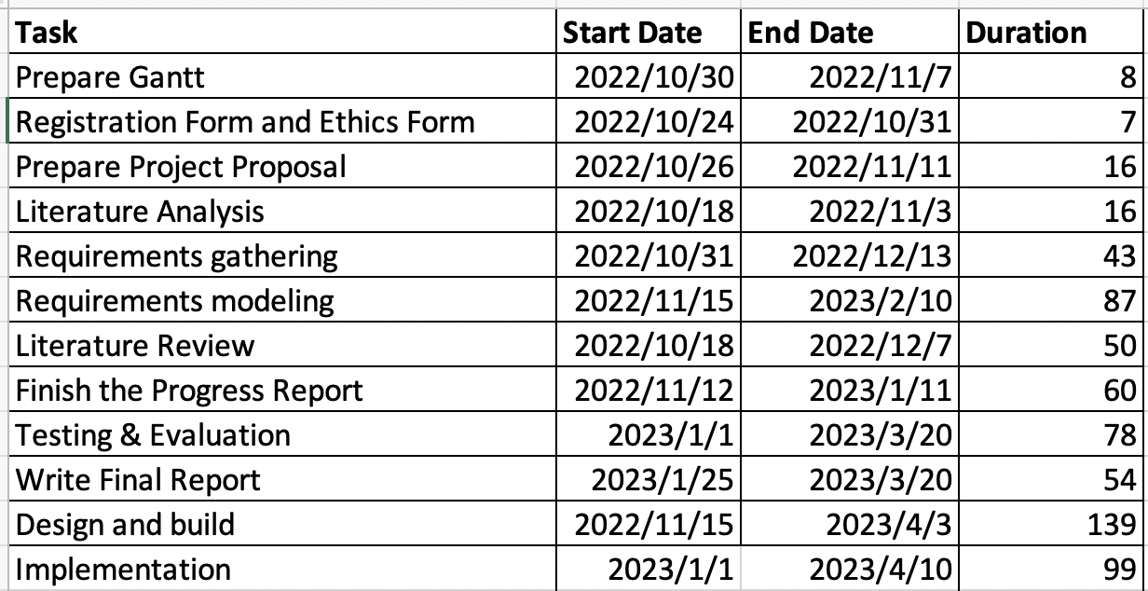

Figure 1: time management

Figure 2: Gantt chart

### **Project Data Management**

Create a local folder and upload it through Google Cloud Service

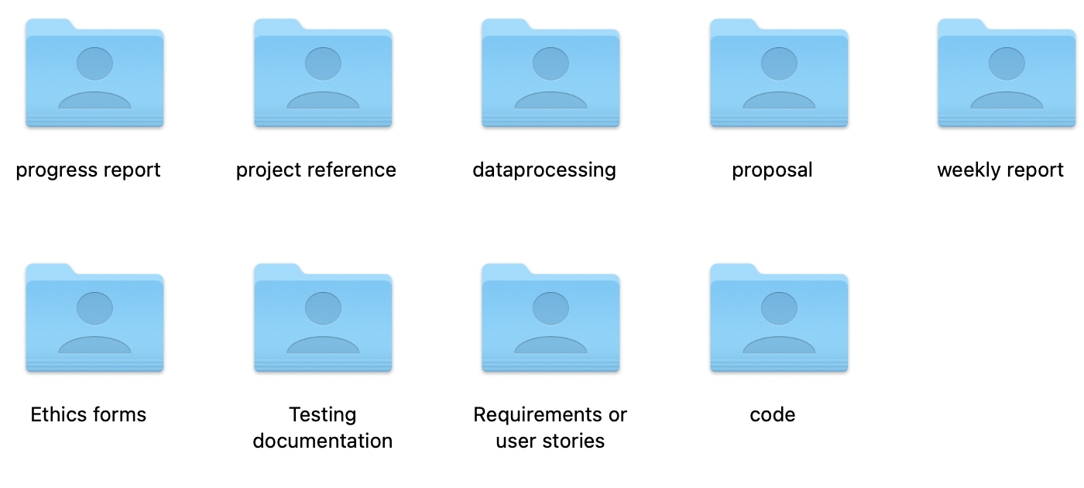

Figure 3: local folder

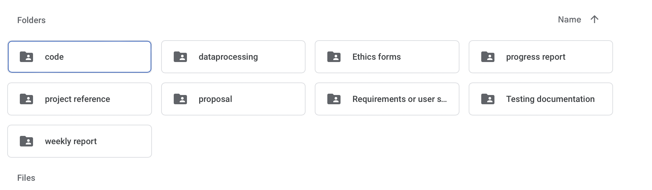

Figure 4: Cloud disk folder

Also, use GitHub to manage the project data:

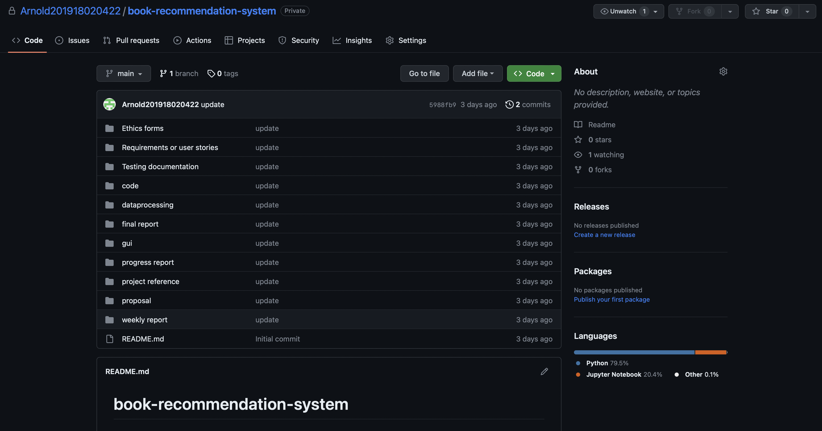

Figure 5: GitHub repository

### Project Deliverables

|  |  |
| --- | --- |
| Submitted | Not submitted |
| 1. progress report | 1. project code |
| 1. project reference | 2.testing data |
| 1. dataprocessing |  |
| 1. proposal |  |
| 1. weekly report |  |
| 1. ethics forms |  |
| 1. Progress report |  |
| 1. testing documentation |  |
| 1. final report |  |
| 1. dataset |  |

Table 2: Deliverables

## **Risk Analysis**

|  |  |  |
| --- | --- | --- |
| **Risk** | **Potential Causes** | **Mitigation Strategies** |
| Data Quality | Incomplete or inaccurate data | Conduct thorough data cleaning and validation procedures prior to training the model. Select data sources based on their reliability and relevance to the problem domain. |
| Model Complexity | High complexity of the Deep and Cross model | Employ thorough testing and validation procedures at each stage of development. Allocate resources to ensure adequate computational power and expertise are available for implementation. |
| Overfitting | Model becomes too closely fitted to the training data | Use regularization techniques such as dropout and L1/L2 regularization. Evaluate model performance on a holdout validation set to ensure that the model generalizes well to new data. |
| Ethical Concerns | Violation of user privacy or perpetuation of harmful stereotypes | Obtain user consent prior to collecting data. Anonymize and encrypt data to protect user privacy. Evaluate fairness and bias in the model design and implementation. |
| Lack of Adequate Data | Insufficient or poor-quality data | Conduct a thorough review of data sources to ensure they are relevant and reliable. Consider using data augmentation techniques to increase the amount of available data. |
| Model Interpretability | Deep and Cross models can be difficult to interpret | Consider using interpretable models or techniques such as SHAP values to better understand how the model is making recommendations. |
| Algorithmic Bias | Bias in the training data or model design | Evaluate the model for bias and take steps to mitigate it. Use diverse and representative data to train the model. |
| Changing User Preferences | User preferences and behaviors can change over time | Consider using techniques such as matrix factorization to update the model with new data. Regularly retrain the model to incorporate changes in user preferences. |
| Scalability | Inability of the model to scale effectively | Consider using distributed computing or cloud-based solutions to increase scalability. Regularly monitor the performance of the model as the number of users and items increases. |
| Hyperparameter Tuning | Improper tuning of model hyperparameters | Conduct a thorough hyperparameter tuning process to identify the optimal settings for the model. Consider using techniques such as grid search or random search to identify the optimal values. |
| Data Security | Risk of data breaches or unauthorized access | Use appropriate encryption and access controls to protect the data. Regularly monitor the system for security vulnerabilities and take appropriate measures to address them. |
| Legal and Regulatory Compliance | Failure to comply with legal and regulatory requirements | Conduct a thorough review of legal and regulatory requirements and ensure that the system is designed and implemented in compliance with these requirements. Regularly review and update the system to ensure ongoing compliance. |

Table 3: risks analysis

By considering these potential risks and implementing the corresponding mitigation strategies,

a general ranking based on the likelihood and potential impact of each risk as follow:

1. Data Quality: Poor quality data can severely impact the performance of the recommendation system and is therefore a high-priority risk.

2. Ethical Concerns: Violations of user privacy or perpetuation of harmful stereotypes can have significant legal and reputational consequences, making this a high-priority risk.

3. Algorithmic Bias: Bias in the model or training data can impact the accuracy and fairness of the recommendations and is therefore a high-priority risk.

4. Model Complexity: The complexity of the Deep and Cross model can lead to issues such as overfitting and longer development times, making this a moderate-priority risk.

5. Lack of Adequate Data: Insufficient or poor-quality data can impact the performance of the recommendation system, and is therefore a moderate-priority risk.

6. Model Interpretability: Lack of interpretability can hinder the ability to explain the recommendations, but may not be as critical as other risks depending on the stakeholders involved.

7. Changing User Preferences: Changes in user preferences can impact the accuracy of the recommendations, but can be addressed through regular retraining of the model.

8. Scalability: Inability to scale may be a concern for larger systems or user bases, but can be addressed through the use of distributed computing or cloud-based solutions.

9. Hyperparameter Tuning: Improper tuning of hyperparameters can lead to suboptimal model performance, but can be addressed through thorough testing and validation procedures.

10. Data Security: While important, data security risks can be addressed through appropriate encryption and access controls, making it a lower-priority risk.

11. Legal and Regulatory Compliance: Compliance with legal and regulatory requirements is important, but can be addressed through thorough review and ongoing monitoring and updates, making it a lower-priority risk.

## **Professional Issues**

Identification and discussion of relevant legal, social, ethical, and environmental issues in the context of the project. Refer to professional codes of conduct, e.g. BCS, ACM.

|  |  |  |  |
| --- | --- | --- | --- |
| **Professional Issue** | **Potential Causes** | **Mitigation Strategies** | **Relevant Laws and Regulations** |
| Legal Issues | Use of Amazon dataset without permission or infringing on intellectual property rights | Obtain necessary permissions and licenses, and adhere to all relevant laws and regulations, such as data protection laws and intellectual property rights | General Data Protection Regulation (GDPR), Copyright Law |
| Social Issues | Use of user data without proper consent or transparency | Ensure that users are informed of how their data will be used, and obtain their consent before using it. Additionally, consider the potential impact of the system on different user groups, and strive to avoid any unfair treatment or biases. | GDPR, e-Privacy Regulation, Fair Credit Reporting Act (FCRA) |
| Ethical Issues | Bias in the recommendation system due to the use of historical user data or other factors | Design the recommendation system to avoid any biases or unfair treatment of certain users or groups. Additionally, ensure that the system is transparent and understandable to users, and that users are made aware of how the recommendations are generated. | ACM Code of Ethics and Professional Conduct, IEEE Code of Ethics |
| Environmental Issues | Energy consumption and environmental impact of training and running the deep learning model | Consider the energy consumption and environmental impact of training and running the deep learning model, and implement strategies to reduce the impact, such as using more energy-efficient hardware or optimizing the training process. | Energy Star, EPEAT |

Table 4: professional issues

Examples of potential causes for legal issues may include scraping data from Amazon without obtaining permission, or using data that is protected by copyright or other intellectual property rights without obtaining the necessary licenses.

For social issues, examples of potential causes may include collecting and using user data without their consent, or using data in a way that is not transparent to users. This can lead to user distrust and may result in negative social consequences.

Examples of potential causes for ethical issues may include using historical user data that is biased towards certain groups or characteristics, or using other factors that may introduce bias into the recommendation system. This can result in unfair treatment of certain users or groups and may have negative ethical implications.

Finally, for environmental issues, examples of potential causes may include using inefficient hardware or training methods that consume excessive energy or resources. This can have negative environmental consequences and may contribute to climate change.

# **Conclusion**

Summary of what was achieved and potential future work.

# **References**

* The layout above is a suggestion of how to present your Final Project Report. Whenever appropriate, introduce sections that will help the readability of your work.
* The Length of the final report should be **8000 – 10000 words**.
* All sections and subsections should be numbered for cross-referencing purposes.
* Regarding citations and references, students must adhere to the University guidelines or IEEE referencing style. **Students doing software development-based projects can cite related websites, web applications, developer documentation, etc. They can cite related articles to their projects, but it is not required. Students doing research-oriented projects should focus on citing research articles. They can also cite appropriate websites whenever necessary. Students are advised to use appropriate reference management software such as Mendeley Reference Manager or Zotero to ensure the correctness of all references.**

## **Formatting Requirements**

Your written report must be presented in the following format:

* All main sections/chapters should begin on a new page. The Declaration page, Tables of Contents pages, Acknowledgment, Abstract, Abbreviation, Glossary, Project Chapters (Chapters 1 to 6), and Appendices should all start on a new page.
* It must be word-processed in 11-point Arial font.
* It must be black text on a white or ivory background
* All pages must be numbered. Follow the appropriate page numbering format specified in the template.
* Margins must be as follows: Top: 1 inch, Bottom: 1 inch (2.5 cm), Left: 1.25 inches, Right:
* 1.25 inches (3.2 cm)
* Use a line spacing of 1.5
* Numbers and captions to figures and tables should be at the bottom of the figure or table. If the figure or table is mounted sideways into the report, then its bottom is on the right-hand side of the report. **All tables and figures must be labeled**.
* Normally, the report should not contain more than 80 tables/figures.

## **Written Presentation**

* The final project report must have a concise written presentation and referencing style.
* It should also have a clear & logical presentation.

**NOTE:**

1. **All the text in red colour are basic guidelines and must be DELETED after using this guide.**
2. **Finally, update the “Table of Contents” appropriately to display the correct section titles and corresponding page numbers.**

# **Appendices**

This section can have the essential information/data that are necessary to be included within the report but would disrupt the flow of the main argument. This section is not marked. Examples include links to data and software repositories, questionnaires, raw survey results, and wireframes.